

**COMSATS UNIVERSITY ISLAMABAD**

**LAHORE CAMPUS**

**Topics in Software Engineering I**

**CSE 350**

**Submitted By : Marwa Khalid FA19-BSE-083**

**Hamza Rana FA19-BSE-089**

**Nimra Aftab FA19-BSE-031**

**Section : A**

**Submitted To : Dr. Fatima Sabir**

**Date of submission : Monday, October 3, 2022**

Submission Oct 3, 2022 till 10AM.

**Assignment 1 Marks 10**

Enable the project using any IDE for code review. It would be better to use Eclipse or Netbeans. You may use VS Code too.

1. Explore your project and find all options discussed in lecture 2 from Chapter 2. You need to prepare a google doc that highlights the potential issue that your code has. You may identify these issues with the help of

i) Identify deprecated technology or APIs. Just report the diagram.

ii) Potential issues missing in the documentation but available in the code

iii) missing of technical documentation ( if applicable )

solution:

there isnt any documentation for the given code.

1. Use PMD to help identify potential coding errors and customize the rules you use to make sure only pertinent rules are applied to your source code.
   1. Create & view code issues directly from your editor
   2. Track & prioritize code improvements like technical debt
   3. Check your code quality
   4. Apply at least 3 PMD rules with the help of tool
   5. Generate the Abstract Syntax Tree of your source code suing PMD.

Solution:

**1. Class name does not match naming convention**

Class name starts with capital letter i.e FoodCart

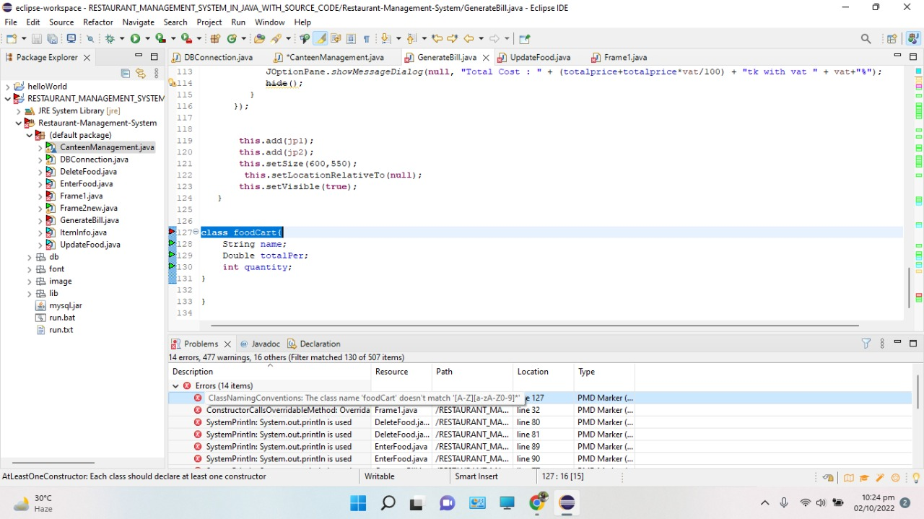

**2. using System.out.println is not a good practice**

System.out.print is used instead of system.out.println as it is used as a defect in PMD plugin.

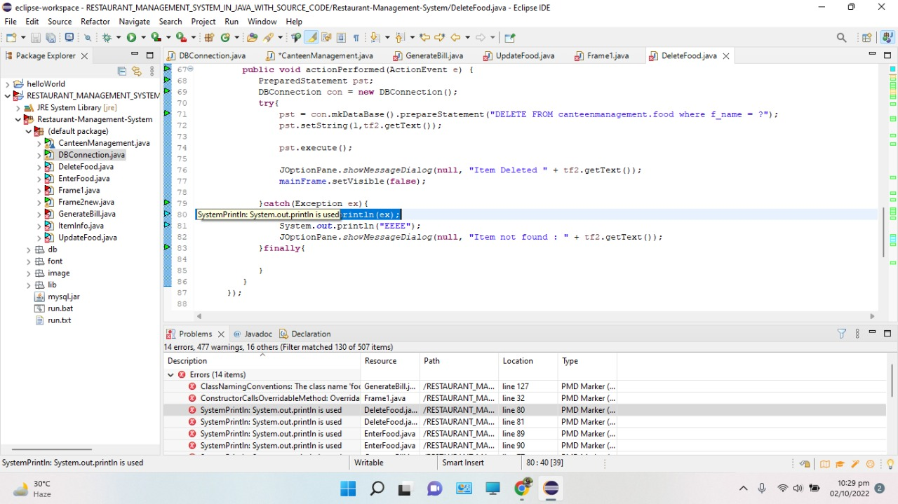

**3. Constructor is calling over rideable methods it unnecessarily opens up possibilities to many bugs. When the @Override is invoked, the state of the object may be inconsistent and/or incomplete.**

You could use static factory methods to fix the problem.

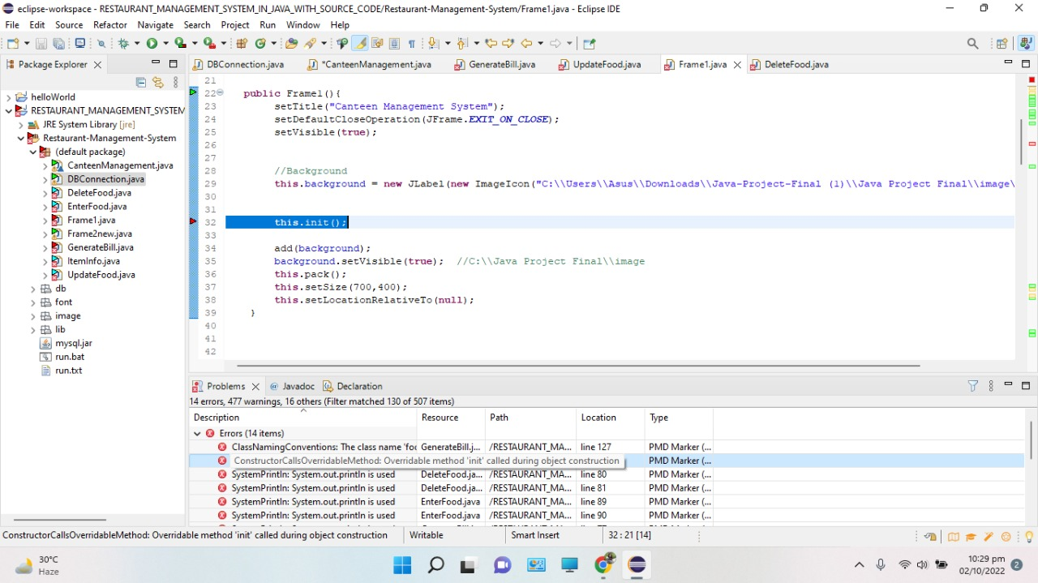

**4. Each class should declare at-least one instructor**

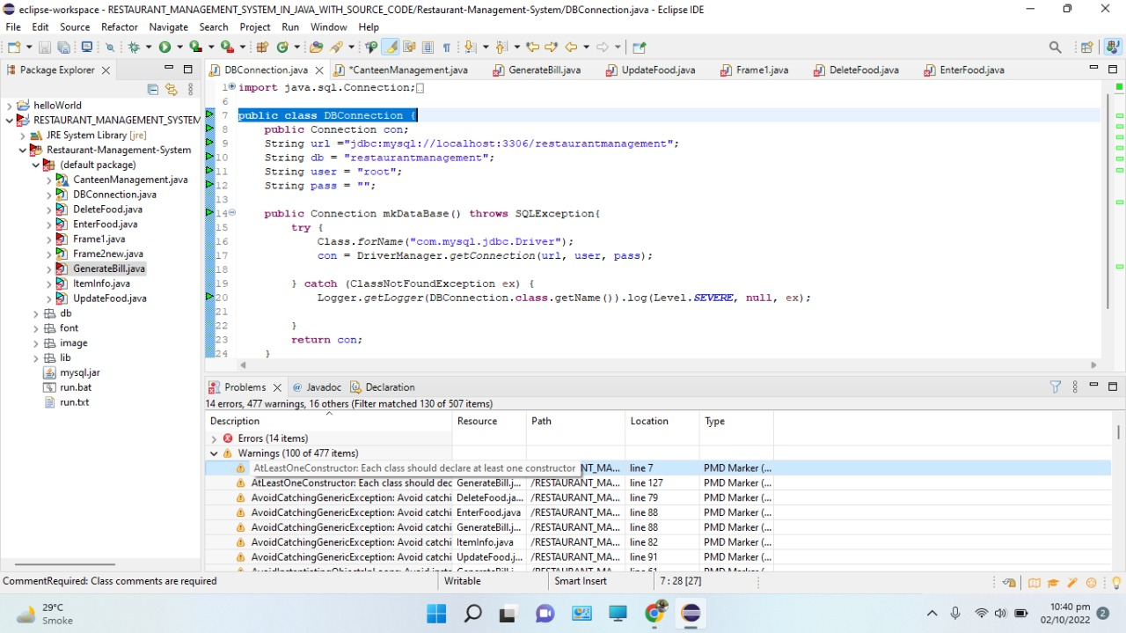

* **After the correction of these errors, the code was running successfully.**

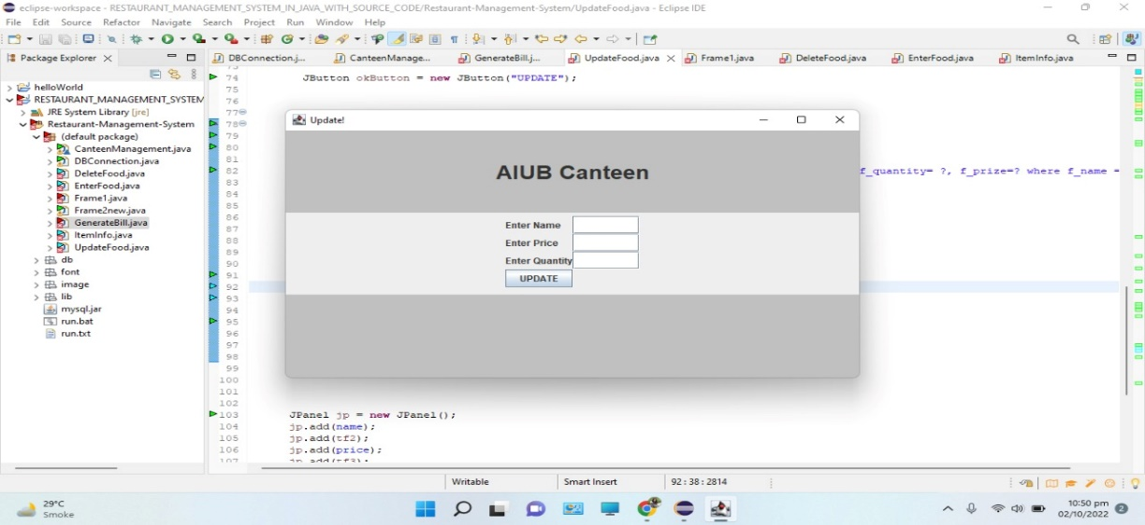

1. Use the Check Style tool to review your code. At least apply 2 rules on your code using CHeckStyle
   1. local variables are being declared but not used.

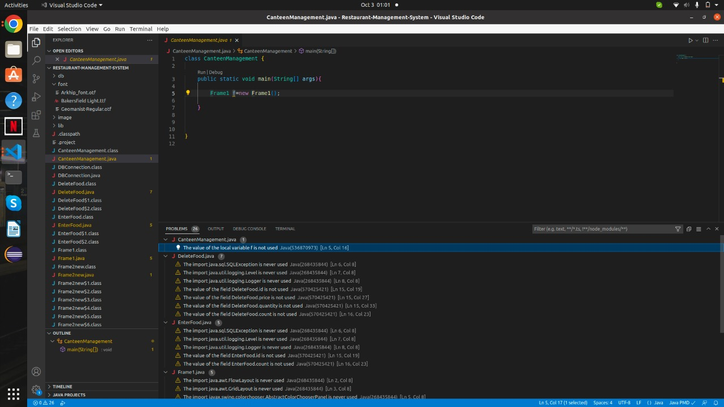

* 1. libraries are being imported but not used

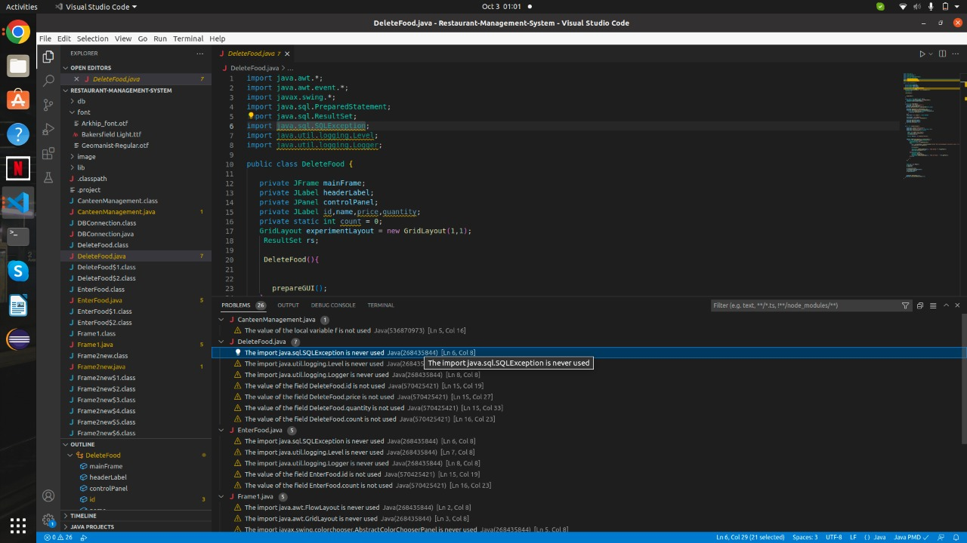

* 1. the method is deprecated

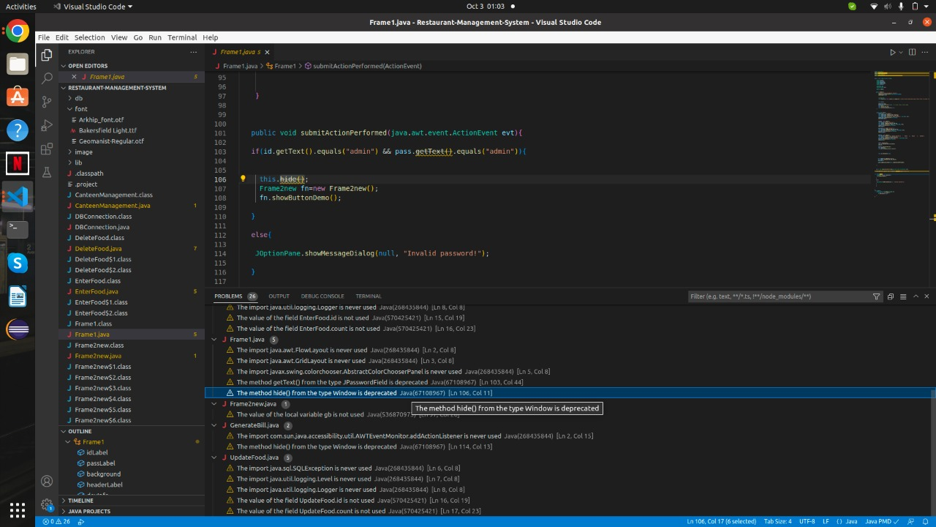

Submit the report of the project on Github

Error free Code link: https://github.com/marwa-khalid/restaurant-system_Assignment1/